Contents
How to Take Control of a Semantic Model in Power BI 2
How to Take Ownership of Power BI dataflow 4
Troubleshooting on App Usage Statistics Missing 8
Workflow Figure of Power Automate and Dataflows 10

How to Take Control of a Semantic Model in Power BI
Ensure that the Power BI workspace is configured under your Microsoft Entra ID account. Follow these steps to ensure a smooth transition:
- ​Log In to Power BI.
- ​Go to the 'Workspaces' menu and select the specific workspace you need to take over
- ​Within the workspace, locate and click on 'Semantic model' and then select 'Settings'.
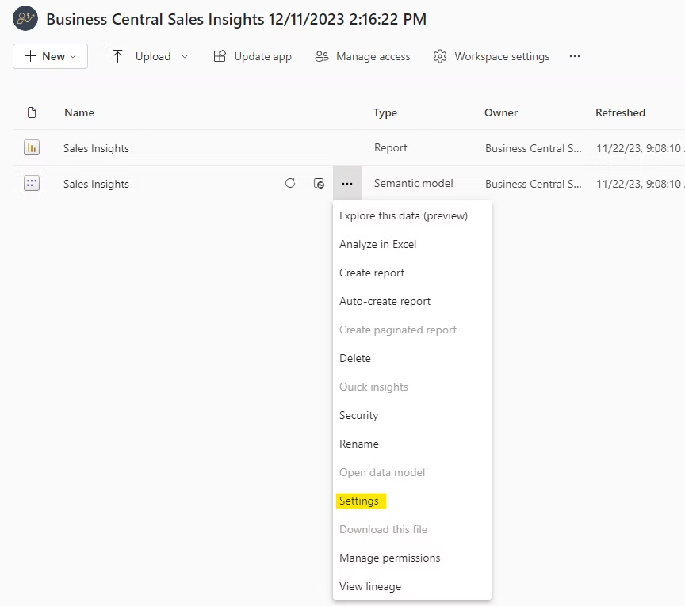

- Verify that the semantic model is configured under your account.
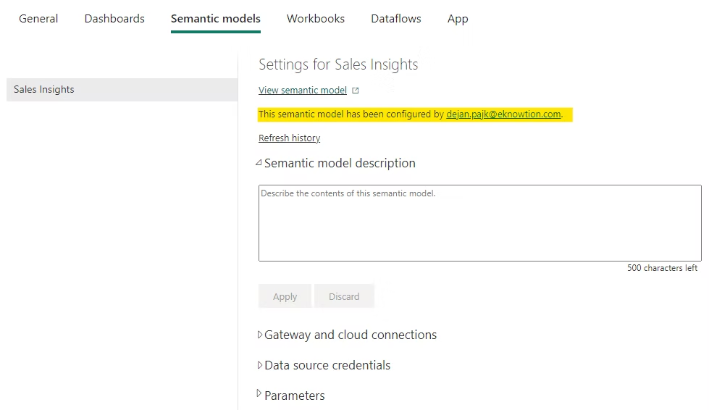
Click the “Take over” button to assume control. Re-authenticate your account after taking control.
Do this by selecting “Edit Credentials” and following the prompts.
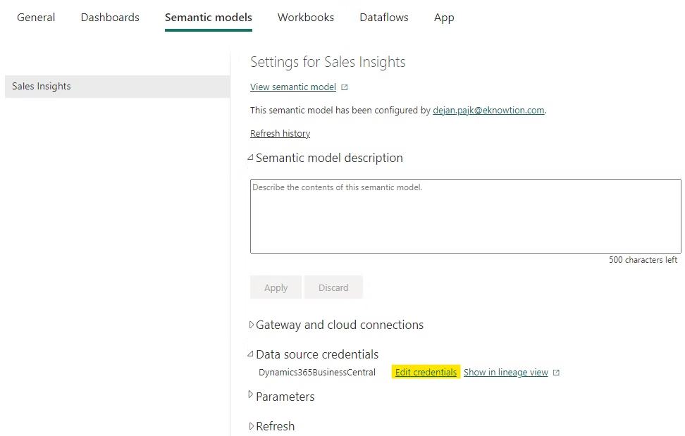
By following these steps, you'll successfully take control of the semantic model

How to Take Ownership of Power BI dataflow
Taking over ownership of a Power Platform or Power BI dataflow requires Environment Administrator or Workspace Admin privileges
- Access the Dataflow Settings: Navigate to your environment via Power BI Home or the Power Apps Portal, locate the workspace or solution containing the target dataflow, and select Settings
Environments: O-Army PPCoE, O-DIS PPCoE, O-RSAF PPCoE, O-RSN PPCoE
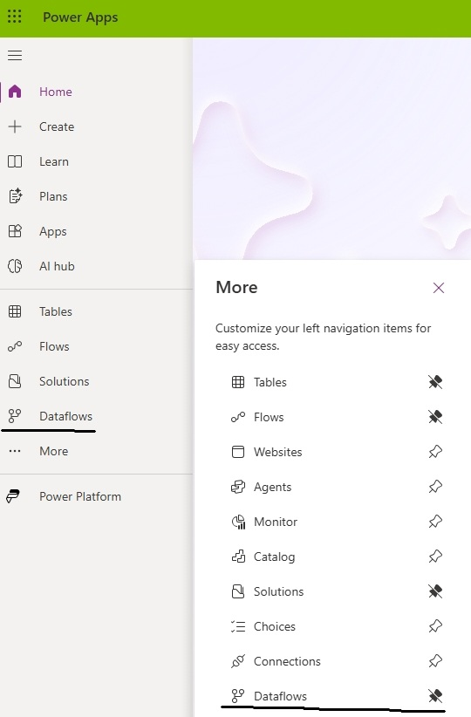

- Execute the Takeover: Find the current owner's name and click the Take over button. Confirm the prompt; this action binds your user account to the dataflow
* Note – There are 8 dataflows per environment
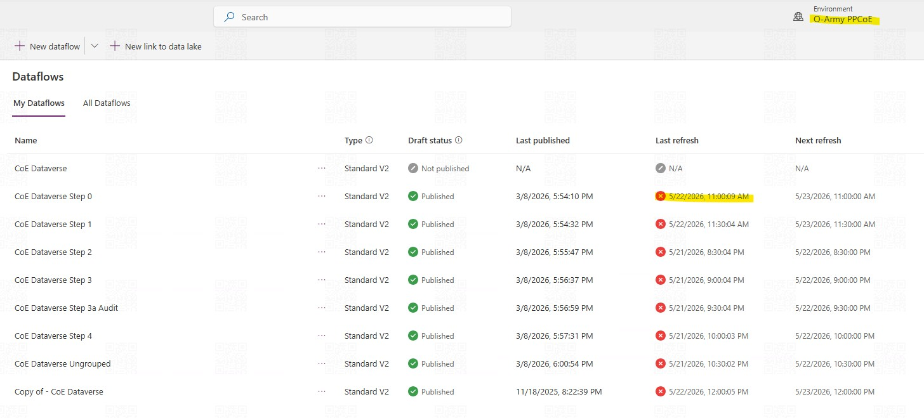
- Update Credentials: Because ownership has transferred, the original owner's stored credentials have been stripped. You must open the dataflow again, navigate to the data sources, and edit the credentials using your own account or a shared service account
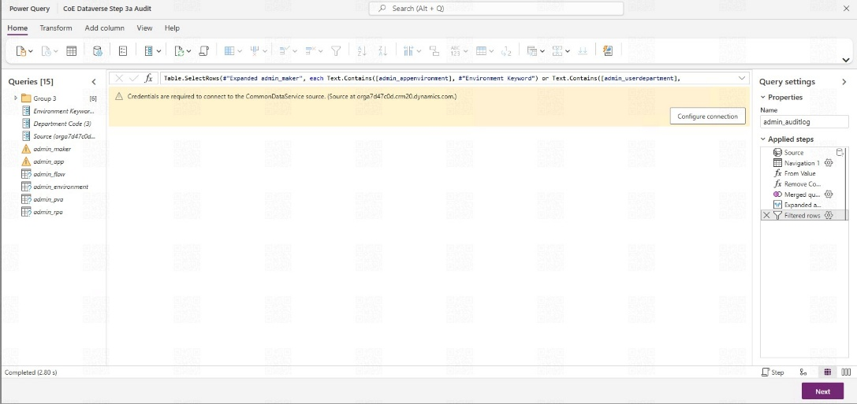
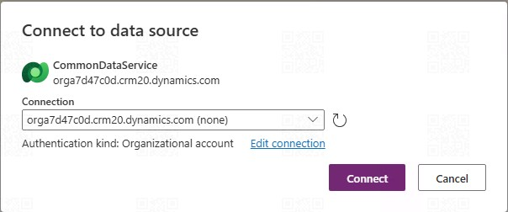

- After updating Credentials, please click on Refresh settings, select Refresh automatically (No change in time) and Save
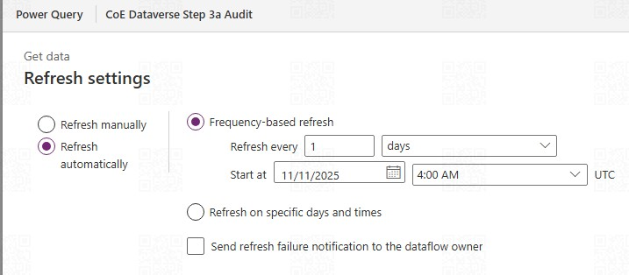

- Screenshots of the Refresh Timing each Environment’s Dataflows
O-Army PPCoE – 11am, 1130am, 830pm, 9pm, 930pm, 10pm, 1030pm, 12am

O-DIS PPCoE – 11am, 1130am, 12pm, 1030pm, 1pm, 130pm, 2pm, 1230pm
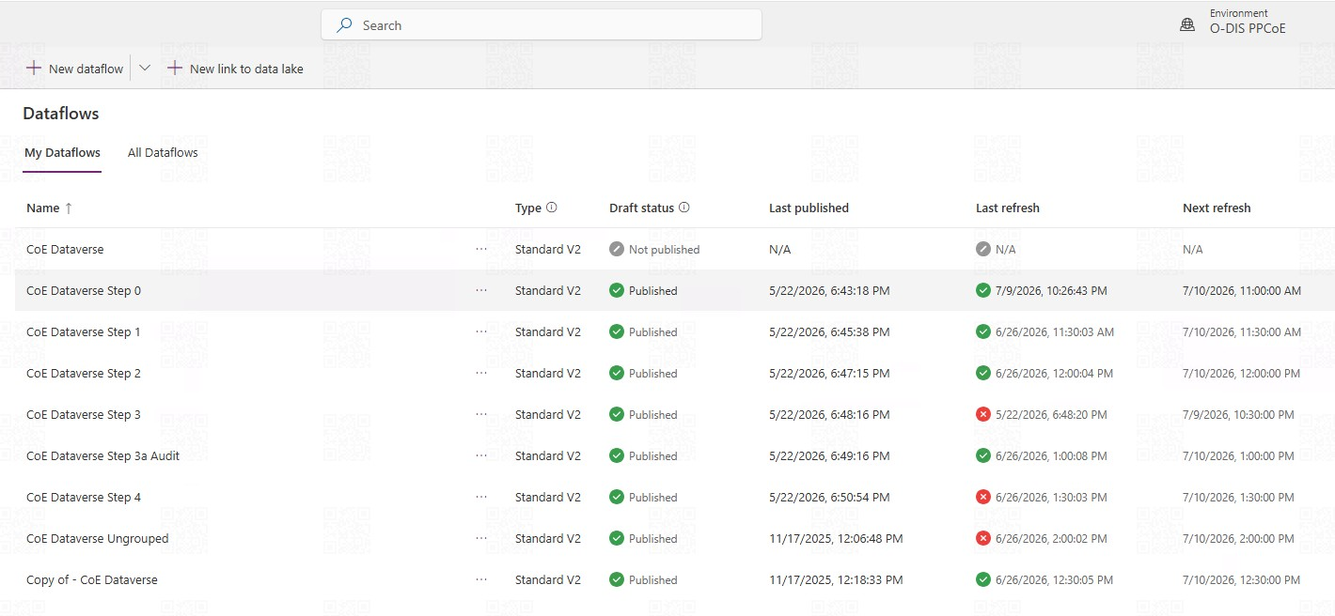
O-RSAF PPCoE – 11am, 1130am, 12pm, 1230pm, 1pm, 130pm, 2pm, 12pm
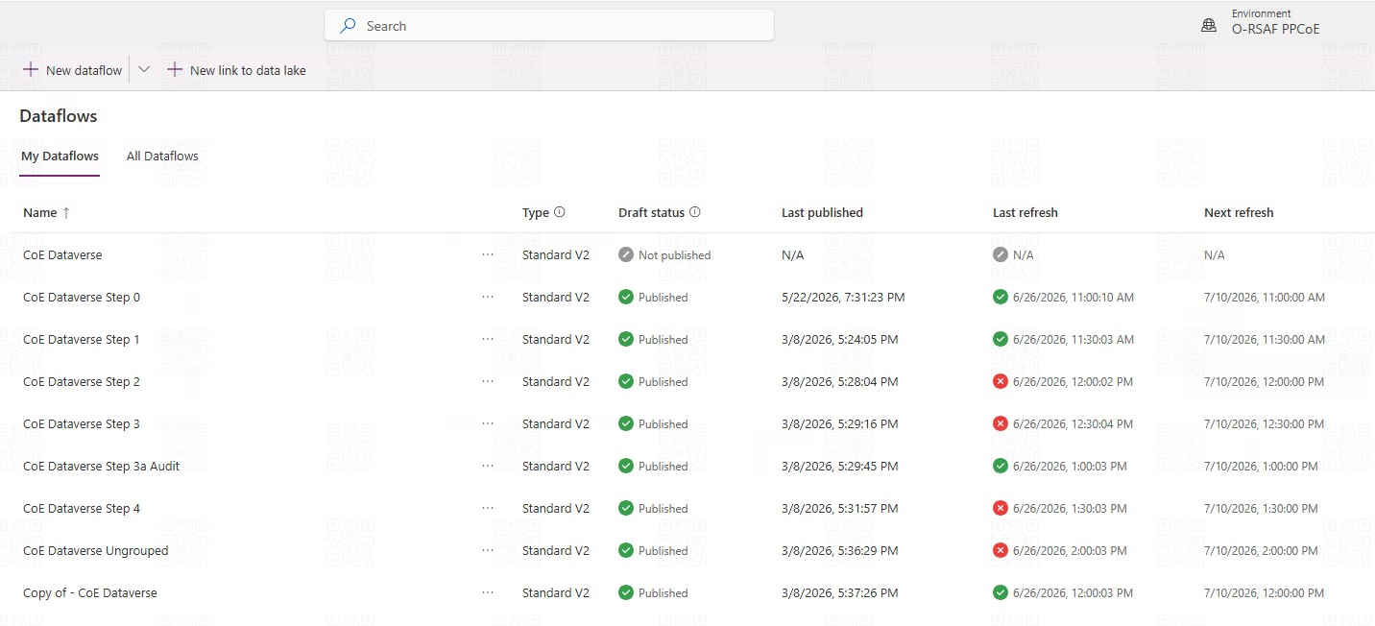
O-RSAF PPCoE – 2am, 11am, 1130am, 12pm, 1230pm, 12pm, 1pm, 130pm
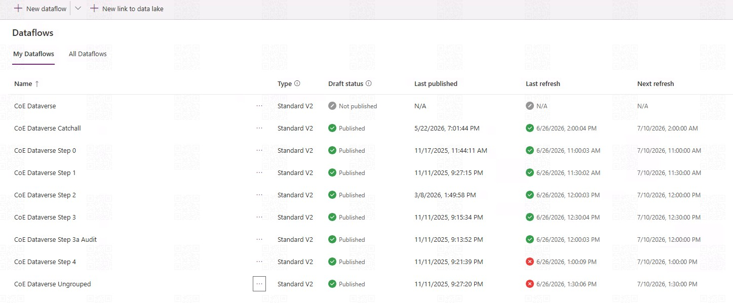

Troubleshooting on App Usage Statistics Missing
Checking the below Power Automate flows
- Admin | Audit Logs | Update Data (V2) flow. This flow updates the Power Apps table with information about the last launch. It also adds metadata to the audit log records.
- Admin | Audit Logs | Sync Audit Logs (V2) flow. This flow runs on an hourly schedule and collects audit log events into the audit log table.
Both flows need environment variable Audit Logs - Client Secret. The app registration client secret (not the secret ID, but the actual value) in plain text. This application client secret comes from the Microsoft Entra app registration for the Office 365 Management API access. See below screen for more details
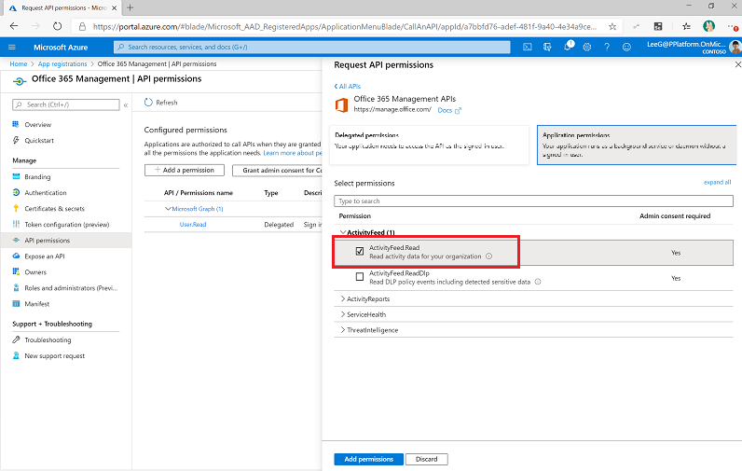

To update Audit Logs - Client Secret, use the CoE Admin Command Center App
- Go to Power Apps and select your CoE environment.
- Open the CoE Admin Command Center app.
- Select the Environment Variables screen.
- Select an environment variable to update, and then select Edit from the navigation bar.
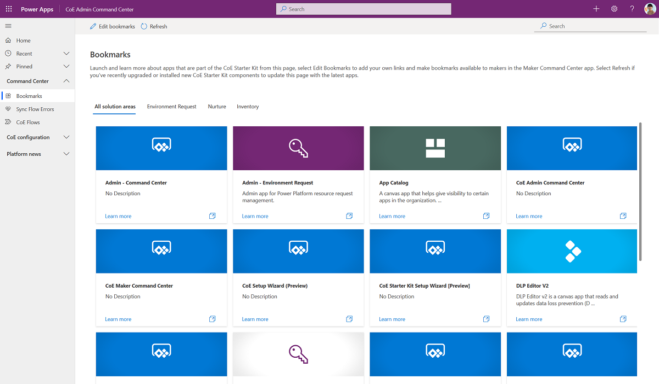

Workflow Figure of Power Automate and Dataflows
Office 365 Audit Log
Dataflows
Filter by Environments
Environment
O-Mindef PPCoE
Dataverse
Environment
O-DIS PPCoE
Dataverse
Environment
O-Army PPCoE
Dataverse
Environment
O-RASF PPCoE
Dataverse
Environment
O-RSN PPCoE
Dataverse
Environment
O-Ops PPCoE
Dataverse
Power Automate
Admin | Audit Logs | Sync Audit Logs (V2)

